GSK Excel Integration Functional Requirements

Revision History
Date | Revision | Description | Contributors
09/07/2007 | V1 | Initial Draft | Lenny Gutnikov

Table of Contents
Revision History 2
Table of Contents 3
1. Introduction 4
2. Requirements 5
3. Detailed Solution 5

Introduction
This document contains the system and functional requirements for the GSK Excel Integration. BioAssay Excel Integration is an extension to BioAssay that will integrate Excel to BioAssay. The user is able to select rows of data from the Primary, Calculation, Additional, and Summary data tables for the Excel Integration. A configuration interface lets the user specify how the data is organized when it is exported to Excel. The interface allows the user to specify such things as which data is exported, how it is organized into columns in Excel, their sorting order, and the name of a macro to run once the data is imported into Excel. Additional parameters may be passed for use during the Excel session. Once the Excel session has ended, the data is sent back and inserted into BioAssay.

Requirements
This Excel Integration will support Microsoft Office Excel versions 2002, 2003, and 2007.

Detailed Solution
  - A new item on the Actions menu in the BioAssay data table interface called “Excel Analysis….”
    - 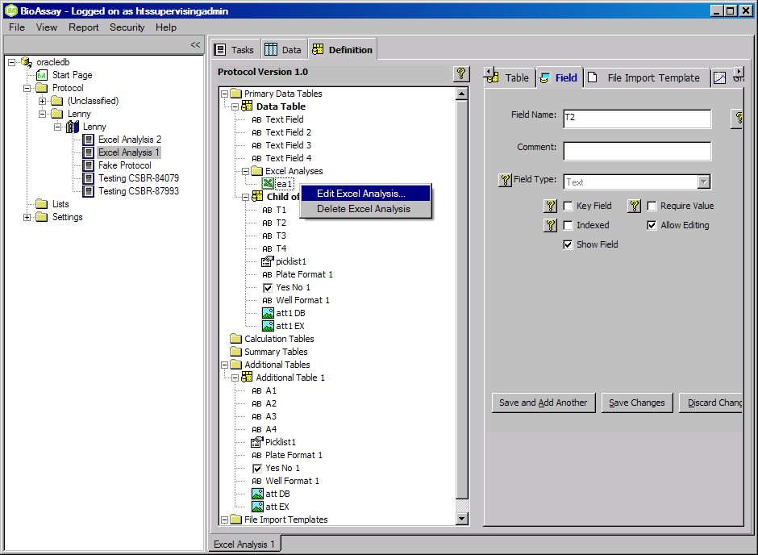
  - Ability to export data from BioAssay into an Excel spreadsheet. Exported data includes one or more A rows (chosen by the user) from the top level table (typically the Experiment table) and all child table data rows. The configuration interface offers a column chooser to select which columns to export to Excel. The configuration interface must be able to specify fields from any view within an experiment i.e. Primary tables, Summary tables and Calculation tables.
  - The configuration interface specifies how the data is organized when it is exported to Excel. The interface allows for the specification of the order of the columns and the priority in sorting and the direction they are sorted. Columns of data will be exported with appropriate column headers in Excel to aid in data organization.
  - The configuration interface optionally specifies a macro to run after data has been imported into Excel.
  - The configuration interface also specifies the File Import Template to use with the Excel Analysis. This feature uses BioAssay’s existing File Import functionality to import the results of the Excel Analysis back into BioAssay. The results of the Excel Analysis are placed in a sheet named “BA_Analysis_Results”. It is up to the user’s Excel macro to place the results of the analysis into this sheet. The contents of this sheet then get imported into BioAssay
  - The configuration interface also allows the user to pass additional parameters to Excel for use in the Excel Analysis. These parameters will be sent to Excel and made available to the Excel session, so that they can be used by a macro/add-in or Excel formulae. Examples of parameters may include UNC file paths, analysis descriptions etc.
    - 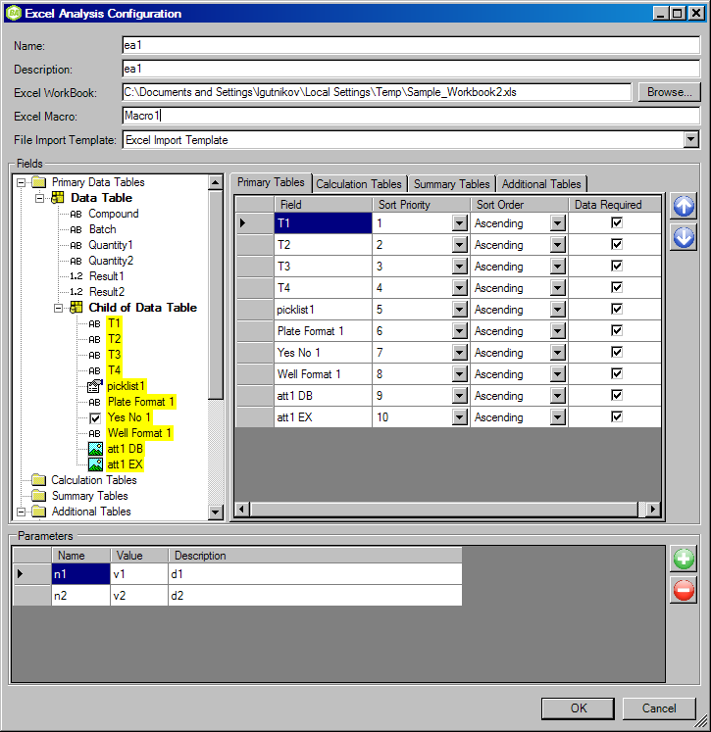

    - To run the Excel Analysis, in the Data Tab of BioAssay select one or more rows from the Primary Table in which the Excel Analysis is defined → right click → “Run Excel Analysis…” → select the Excel Analysis you want to run. This will launch an Excel session.

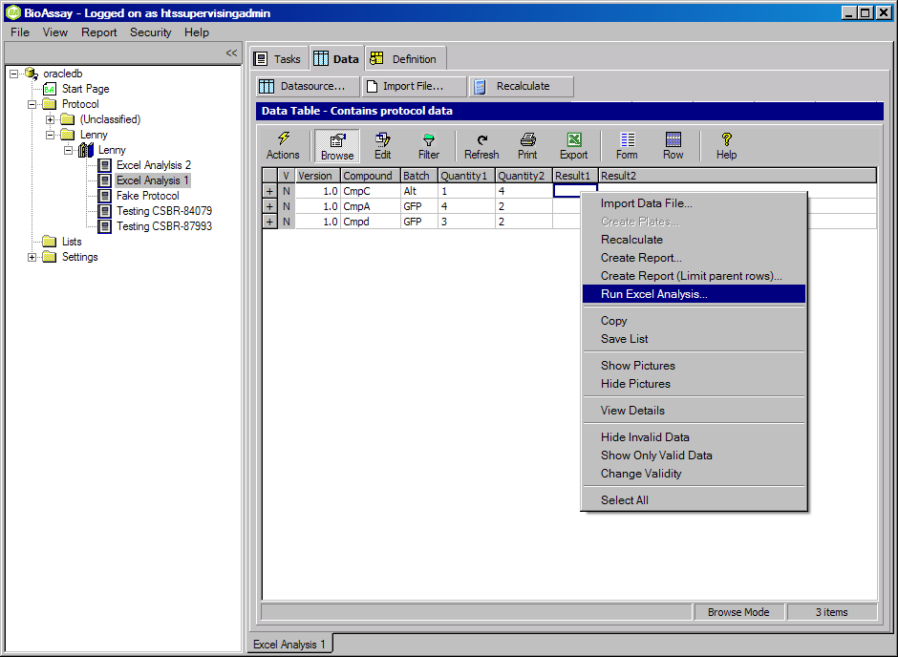

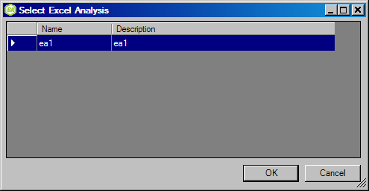
  - The BioAssay data that is passed to Excel is organized as follows:
- Data selected from any table in the Primary Table hierarchy will go into a sheet named “BA_P”.
- Data selected from each of BioAssay’s Calculation Table hierarchies will go into a separate sheet starting with the name “BA_C-“ followed by the name of the top level table.
  - For example, if you have two Calculation Table hierarchies such as
Calc Table 1
Calc Table 2
Calc Table 3
Calc Table 4
Then there will be two sheets named “BA_C-Calc Table 1” and “BA_C-Calc Table 3”
- Data selected from each of BioAssay’s Summary Tables will go into a separate sheet starting with the name “BA_S-“
  - For example, if you have two Summary Tables named “Summary Table 1” and “Summary Table 2”, then there will be two sheets named “BA_S-Summary Table 1” and “BA_S-Summary Table 2”
- Data selected from each of BioAssay’s Additional Tables will go into a separate sheet starting with the name “BA_ A-“
  - For example, if you have two Additional Tables named “Additional Table 1” and “Additional Table 2”, then there will be two sheets named “BA_ A-Additional Table 1” and “BA_ A-Additional Table 2”
- There will be a sheet named “BA_Parameters” that contains parameters passed to Excel from BioAssay. These parameters get defined in BioAssay.
- There will be a sheet named “BA_Analysis_Results” that gets filled with data by running the user’s macro.
- There will be a sheet named “BA_Prompt_Me” with the names of the “Prompt Me” fields that are defined in the BioAssay File Import Template that is used with the Excel Analysis. It is up to the user to fill in the values for each of these fields.
- 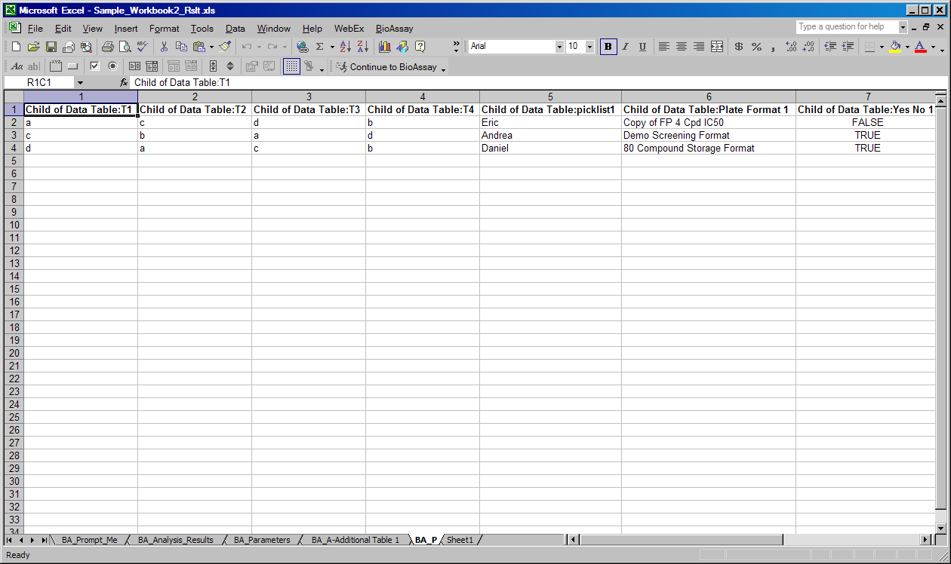

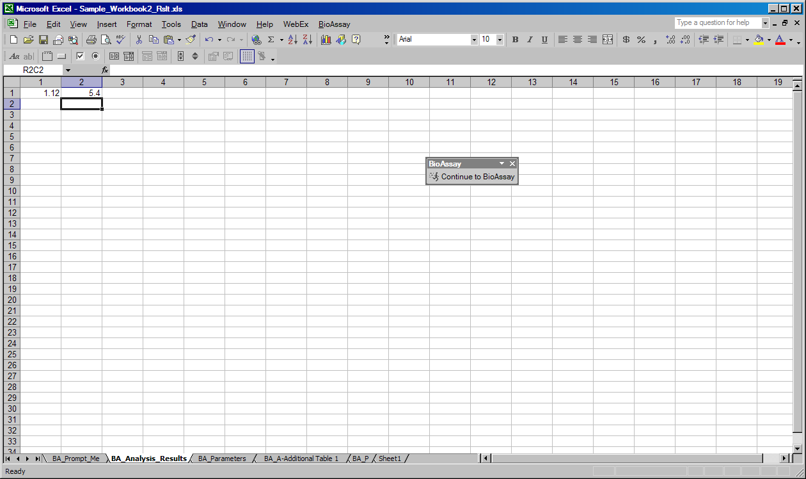
  - The Excel session has the ability to send the results of the Excel Analysis back to BioAssay.
  - The results of the Excel Analysis are imported back into BioAssay according to the File Import Template assigned to the Excel Analysis
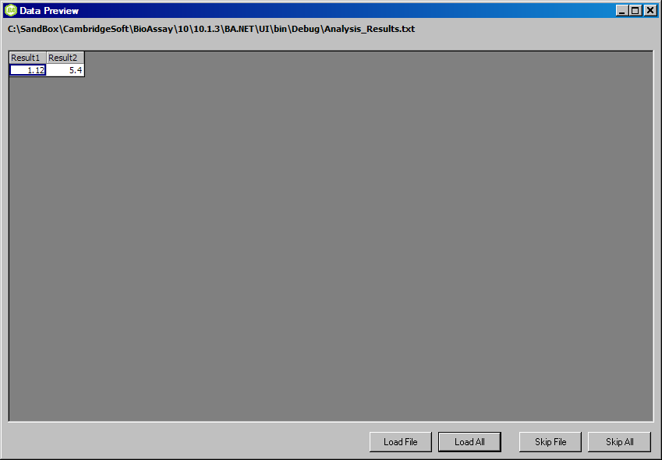
  - Importing results back into Bioassay (see 3.1.5 and 3.1.6) will be managed by the BioAssay File Importer. Therefore it will prompt users for values where specified in the configuration. Two changes are required to the importer to allow this integration to work efficiently:
- The ability to load data directly from Excel. This can be specified as the sheet index in the import definition and\or a prompt for a sheet name in the import wizard.
- The ability to choose how existing data is dealt with when data is imported, This can be specified in the import definition and/or as an option in the import wizard. The options are:
  - Overwrite – overwrite existing data with new data.s
  - Don’t Overwrite – don’t overwrite any existing data (equivalent to the current file import data merge algorithm employed by the BioAssay file importer).
  - Warn – the user is warned if data is about to be overwritten. At this time the user has the option to cancel the action if desired.

Work Flow

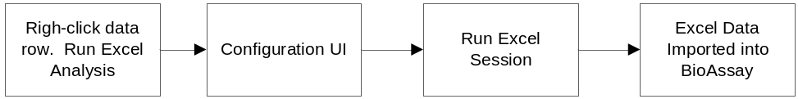

Functional Requirements
  - BioAssay Client
    - The user just be able to define Excel Analyses in the Protocol Definition. A separate folder called “Excel Analyses”.
    - A user must be able to run the Excel Analysis by right-click on one or more data rows in the Primary Table in which the Excel Analysis is defined and select “Excel Analysis…” This launches the Configuration UI.
  - Configuration UI
    - Display the Primary Table hierarchy and allow the user to select which fields get exported to Excel.
    - Allow the user to select fields from the Primary, Summary, and Calculation tables in a similar manner
    - Allow the user to choose the order of the fields selected from steps 5.2.1 and 5.2.2.
    - Allow the user to specify the sorting priority of the chosen fields.
    - Allow the user to specify the sort direction of the chosen columns.
    - Allow the user to specify a macro to be run after the data is imported into Excel.
    - Allow the user to pass parameters to be used in the Excel session.
  - Data Import Into BioAssay
    - Importing results back into Bioassay (see 3.1.5 and 3.1.6) will be managed by the BioAssay File Importer.
  - Data Exchange
    - Data will be exchanged between BioAssay and Excel through intermediate files, which will be invisible to the user.

